**ORGANIZATIONAL OVERDOSE RISK ASSESSMENT TOOL**

INTENDED AUDIENCE

August 2017, 1st edition

The Works Needle Exchange Program

Toronto Public Health

Agencies and/or programs who have staff who work with people who use drugs and/or staff working in areas where drug users may be present and at risk of overdose.

PURPOSE

The purpose of this risk assessment tool is to assist agencies and/or programs to:

* determine the need to plan for overdose response
* determine the level of response that is most appropriate, which may include:
  + training staff to recognize the signs of overdose;
  + monitoring the service space and/or where staff work and the space in and around the organization where people may use drugs
  + raising awareness about overdose risk factors and prevention strategies and;
  + responding to an overdose e.g., calling 911, administering naloxone, CPR.

BACKGROUND

People dying from drug overdoses is an urgent public health crisis across Canada. There has also been a dramatic rise in overdose deaths in Toronto. Between 2004 and 2015, there was a 73% increase in the reported number of overall drug toxicity (overdose) deaths in Toronto (from 146 in 2004 to 253 in 2015). Accidental deaths (i.e. not suicide/undetermined) represent the majority of these deaths, and increased 149%, from 82 deaths in 2004 to 204 deaths in 2015. Opioids, alone or in combination with other drugs, accounted for 135 or 66% of all accidental deaths in 2015. Between 2014 and 2015, the number of people dying from heroin/morphine dropped by 24% (from 76 to 58), but deaths from fentanyl almost doubled (from 22 to 42). Opioid overdose deaths increased by 77% between 2004 and 2014 in Toronto, with the majority of deaths due to opioids such as heroin and fentanyl[1].

OPIOIDS AND OPIOID OVERDOSE

Opioids belong to a group of drugs known as depressants. Depressants are substances that slow the body down and can make people sleepier. Opioids may be prescribed or used illegally to reduce pain, manage opioid dependence, or produce a state of relaxation. Common opioids include heroin, fentanyl, morphine, methadone, codeine and oxycodone.

Opioid overdose occurs when an opioid or an opioid combined with other substances overwhelms the body and as a consequence the central nervous system (CNS) is no longer able to control basic life functions (i.e. breathing, heart rate, body temperature, consciousness).

NALOXONE

Naloxone is a medication that reverses an opioid overdose by blocking the effects of opioids in the brain. In Canada, naloxone is available in intramuscular (i.e., injectable) and intranasal (i.e., nasal spray) formulations. Naloxone is available without a prescription to opioid users, their friends and family for use in an opioid overdose, and regulatory changes have made it possible for anyone to administer naloxone with the appropriate training.

Naloxone can reverse the effects of an opioid overdose within three to five minutes. Once administered, naloxone will start to work within 2-3 minutes and can last from 45 minutes to 2 hours. Since naloxone temporarily removes the opioids from the receptor sites in the brain, the effects of naloxone will eventually diminish, the opioids will return to the receptors and the overdose symptoms may return. Subsequent doses of naloxone may be required and medical attention must be sought, Naloxone has no effect in the absence of opioids. If naloxone does not have an effect, the apparent symptoms of overdose may be caused by another condition, making CPR and other lifesaving measures imperative.

The Ontario Naloxone Distribution Program provides naloxone to needle exchange programs and ministry-funded multidisciplinary hepatitis C teams across Ontario. If your program works with clients who are at risk for overdose, their friends and family, you can refer them to a [distribution site or a pharmacy](https://www.ontario.ca/page/get-naloxone-kits-free).

SHOULD YOUR AGENCY/PROGRAM PLAN FOR OVERDOSE RESPONSE?

This decision should be based on the answers to the following question:

* Is there a potential for someone to overdose at your agency/program?

In answering this question, consider the following:

* Do staff regularly work with people who use drugs?
* Do staff work in areas where people might be using drugs?
* Do staff work in areas where people may be at risk for overdose?
* Has there already been an overdose in your agency/program?
* Have any of your clients raised concerns about their overdose risk?
* Do staff currently use opioids or have a history of opioid use?

If you answered yes to any of these questions you should develop an overdose response plan for your program/agency.

You can opt to:

* Raise staff awareness of the potential for overdose, overdose signs and symptoms and how to monitor your space or the surroundings
* Train staff on how to respond to an overdose by calling 911
* Train staff on the need for an urgent response
* Train staff on how to respond to an overdose by administering naloxone, if appropriate

Some staff who could benefit from having naloxone available to them:

* Harm reduction staff
* Shelter staff
* Outreach staff
* Parks Ambassadors
* Staff who work in community agencies like drop-ins, community health centers, etc.
* Staff who provide home visits for clients who may use drugs

WHAT SHOULD BE INCLUDED IN YOUR OVERDOSE RESPONSE PLAN?

1. Staff training on (see below for more information about training):

* Signs of overdose
* Overdose risk factors

2. Strategies to monitor clients and spaces for overdose, including:

* Regularly and systematically monitoring all areas where people may be using drugs or where they may go following drug use.
* Ensuring bathroom doors and doors to other potential areas are easily accessible in the event of an overdose

3. A plan for how to respond to an overdose, including:

* Calling 911
* CPR, using an AED (if available)
* Naloxone administration (if applicable, see below)
* Documentation and notification
* Debriefing post-incident

The above components should be supported by relevant policies and procedures. The Works Program can provide draft policies and procedures upon request.

SHOULD MY AGENCY/PROGRAM HAVE NALOXONE AVAILABLE?

When deciding whether your program should have naloxone available, consider the following question:

* Is there a likelihood that staff will encounter someone experiencing an overdose in the course of their work?

If there is likelihood of encountering someone experiencing an overdose, your program should consider having a supply of naloxone and training for staff on how to use naloxone.

DECISION SUPPORT ALGORITHM

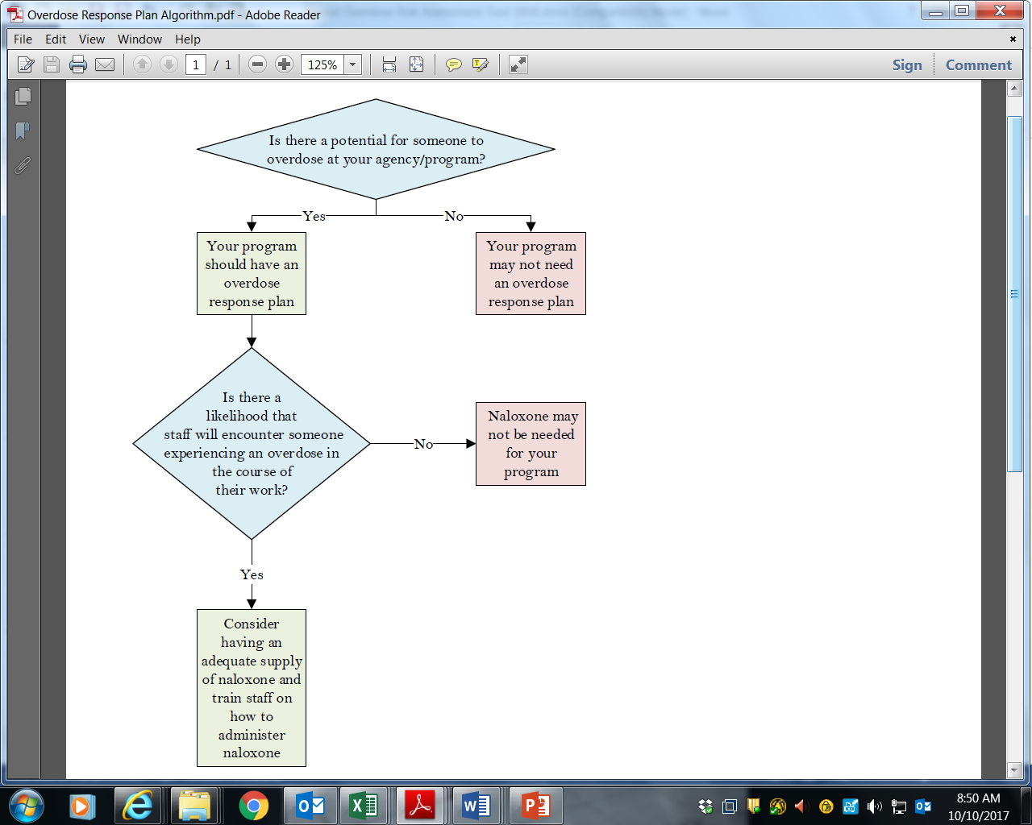

WHAT TYPE OF NALOXONE SHOULD MY PROGRAM HAVE AVAILABLE?

Naloxone is available in both intramuscular (i.e., injectable) and intranasal (i.e., nasal spray) formulations.

a) **INTRAMUSCULAR** Formulation

* **Effectiveness**: The intramuscular formulation may be more effective in those with a history of intranasal drug use and other conditions which may result in scar tissue in the nose, or congestion. Intranasal naloxone is absorbed through the blood vessels in the nose and therefore these conditions may impact absorption.
* **Cost**: The cost of intramuscular naloxone is less than the cost of intranasal naloxone. Intranasal naloxone costs approximately five times the cost per dose of the intramuscular formulation.
* **Availability:** Intramuscular naloxone can be purchased through most community pharmacies. The intramuscular formulation is used almost exclusively by hospitals, paramedics, and other first responders. People with a history of opioid use, their friends and family are eligible to receive a naloxone kit that contains intramuscular naloxone through the Ontario Pharmacists Association publicly-funded Naloxone Distribution Program.
  + **Additional Supplies:** Additional supplies including alcohol swabs, ampoule breakers, resuscitation masks and syringes can also be purchased though most community pharmacies.
* **Existing training supports:** The Works, Toronto Public Health provides overdose response training to community organizations and City of Toronto divisions at no charge.
* **Staff comfort and safety:** Using automatically retracting needles to administer intramuscular naloxone can minimize the risk of needle stick injuries.
  + While there is a risk that someone may be agitated following the administration of naloxone, this may happen regardless of the formulation as both types require close contact[2].

b) **INTRANASAL** Formulation

* **Availability**: Intranasal naloxone must be purchased from the supplier, either directly or through a pharmacy or distributor, and is not widely available in the province. In the future, it is expected that people with a history of opioid use, their friends and family may be able to receive a naloxone kit that contains intranasal naloxone through the publicly-funded Community Naloxone Distribution Program.
* **Existing training supports:** The Works, Toronto Public Health provides overdose response training to community organizations and City of Toronto divisions at no charge.
* **Staff comfort**: People may feel more comfortable with the idea of administering an intranasal product. Intranasal does not require disposal in a container for injection equipment[3].

HOW CAN MY PROGRAM ACCESS NALOXONE AND TRAINING?

**a) Accessing Naloxone**

On June 24, 2016, NAPRA reclassified naloxone as a Schedule II drug when used in an emergency opioid overdose situation outside of hospital settings. This change was effective immediately in Ontario. As a result, naloxone is available over-the-counter in Ontario. The changes in prescription status also enable anyone to administer naloxone when used in response to an opioid overdose. This allows people to respond in settings where health care workers or emergency responders are not regularly employed or available.

You can purchase naloxone through a local pharmacy. If you work for a City of Toronto Division or Program, you can order naloxone through City Stores.

**b) Accessing Training**

Toronto Public Health is providing overdose prevention and response training for staff in City of Toronto divisions, agencies, boards and commissions and staff from community agencies.

Training is being provided on the following topics:

* The overdose situation in Toronto
* Risk factors for overdose
* Signs and symptoms of overdose
* Ways to respond to an overdose, including how to administer naloxone.

Training is currently offered every Monday and Thursday from 1:30 pm to 4:00 pm at various locations throughout the City of Toronto. Registration for the training via [Eventbrite](https://www.eventbrite.ca/e/opioid-overdose-education-prevention-response-tickets-34886736167). Alternatively, staff can access the Eventbrite registration link on the Works webpage.

Online training modules on overdose prevention and counselling (in addition to recognizing and responding to an overdose without naloxone) are also available and can be accessed on The Works [webpage](https://www1.toronto.ca/wps/portal/contentonly?vgnextoid=b59f2acbda21b410VgnVCM10000071d60f89RCRD).

WHO SHOULD I CONTACT IF I HAVE MORE QUESTIONS?

You can contact The Works at [overdose@toronto.ca](mailto:overdose@toronto.ca)

References:

British Columbia Joint Task Force on Overdose Response. (2017). Naloxone Risk Assessment Tool- for Non-public Sector Organizations. Retrieved August 20th from: <http://www2.gov.bc.ca/assets/gov/overdose-awareness/naloxone_risk_assessment_-_non-governmental_sectors.pdf>

Toronto Public Health. Toronto Overdose Action Plan: Prevention & Response Toronto Public Health. March 2017. Retrieved August 20th from: http://www.toronto.ca/legdocs/mmis/2017/hl/bgrd/backgroundfile-101781.pdf

1. Toronto Overdose Action Plan: Prevention & Response Toronto Public Health. March 2017
2. British Columbia Joint Task Force on Overdose Response. (2017). Naloxone Risk Assessment Tool- for Non-public Sector Organizations.
3. British Columbia Joint Task Force on Overdose Response. (2017). Naloxone Risk Assessment Tool- for Non-public Sector Organizations.